**→ Auto Encoders :**

**(1) Auto encoders main algo :**

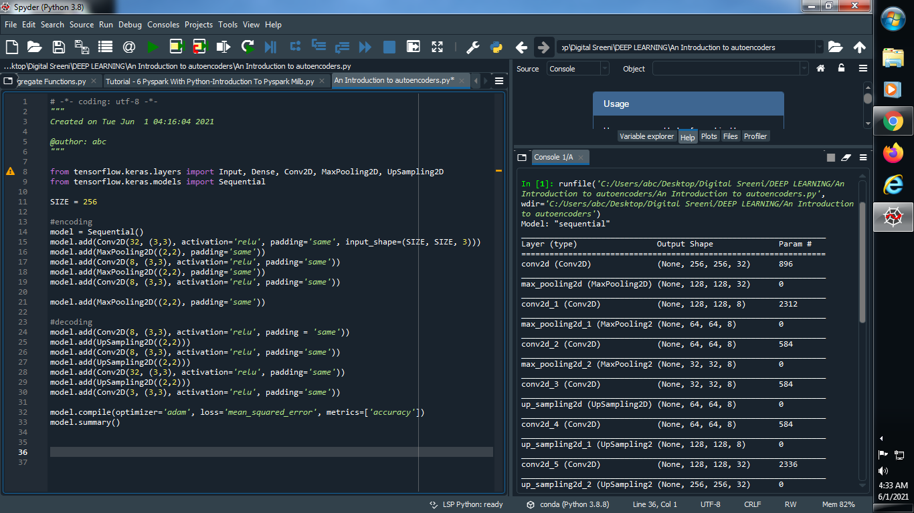

**Output :**

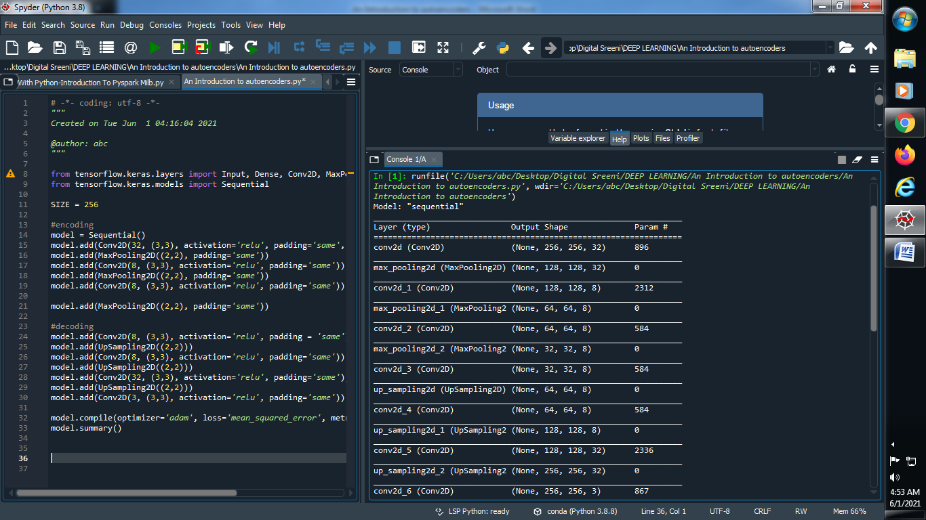

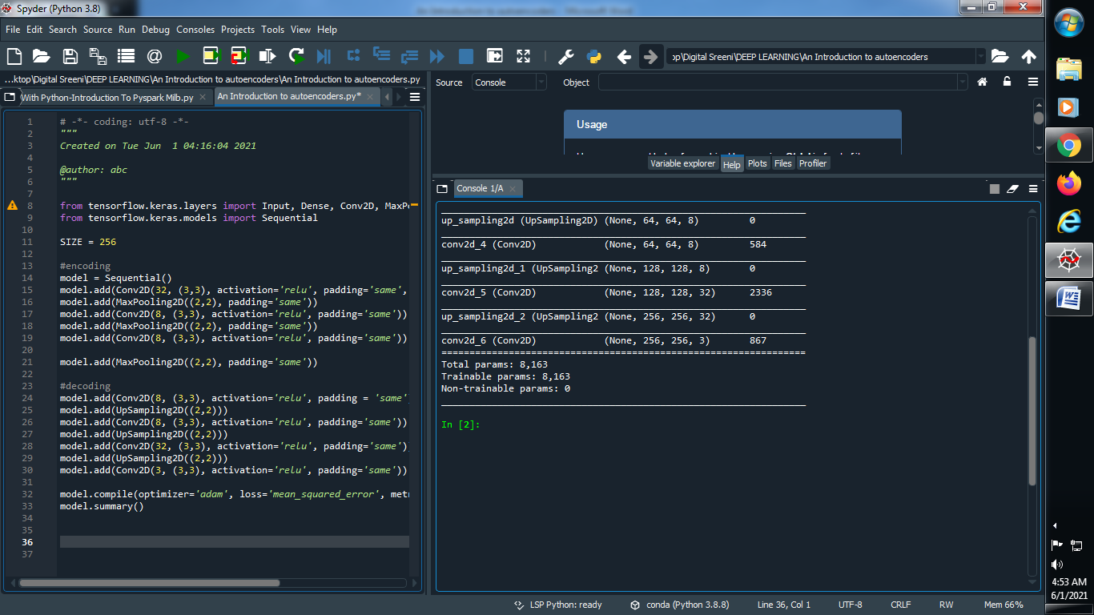

**#############################################################################**

**→Perform auto encoders :**

**(1) Import required library :**

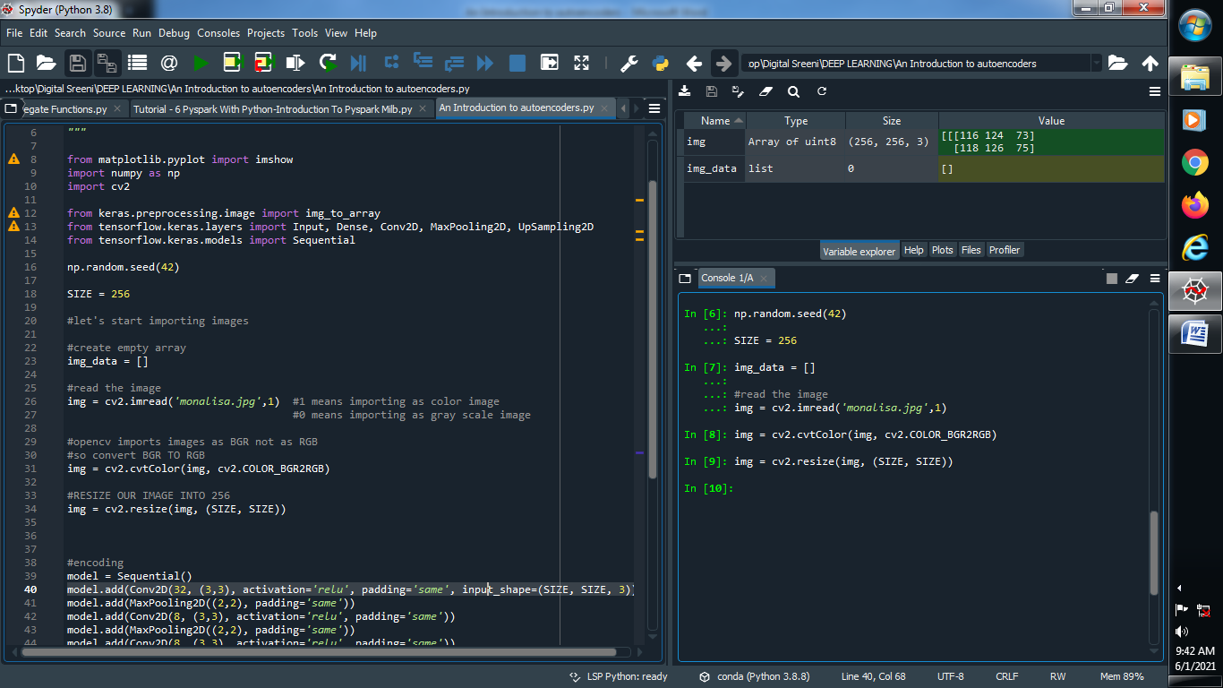

**(2) Define random seed and size :**



**(3) Create an empty array for importing images and read our image :**

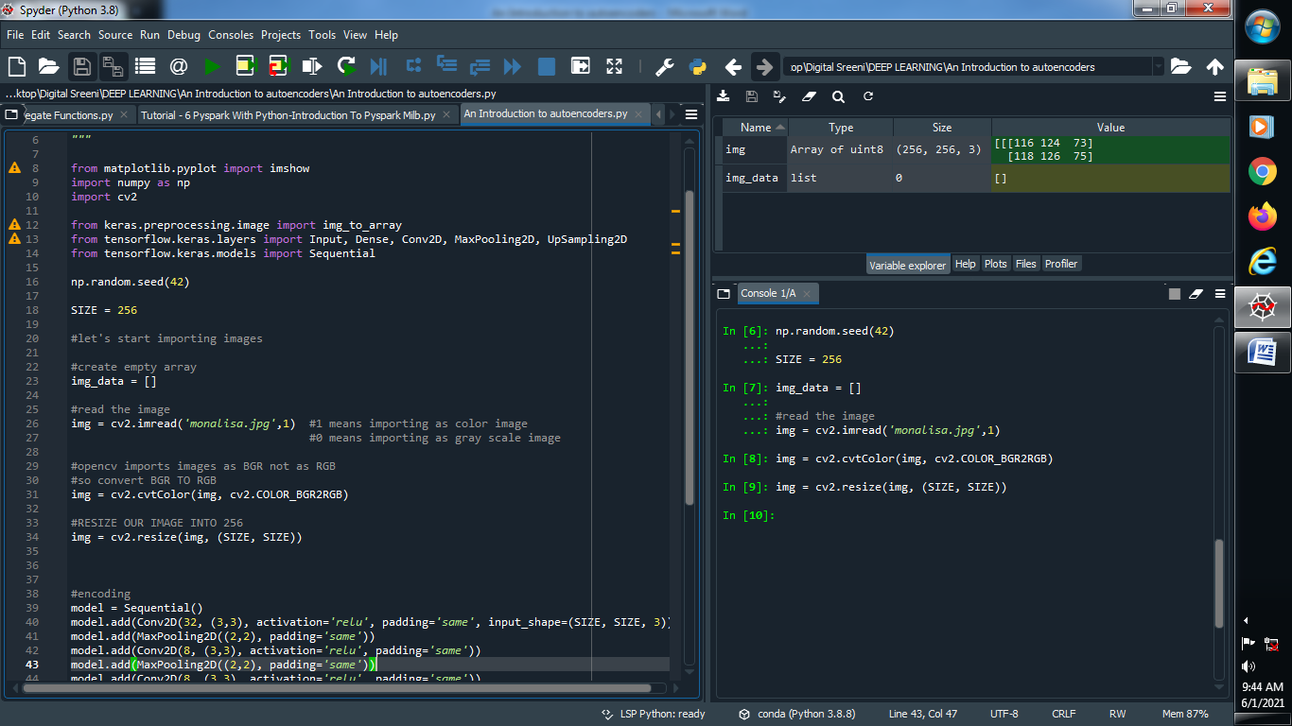

**(4) Convert BGR image into RGB image :**

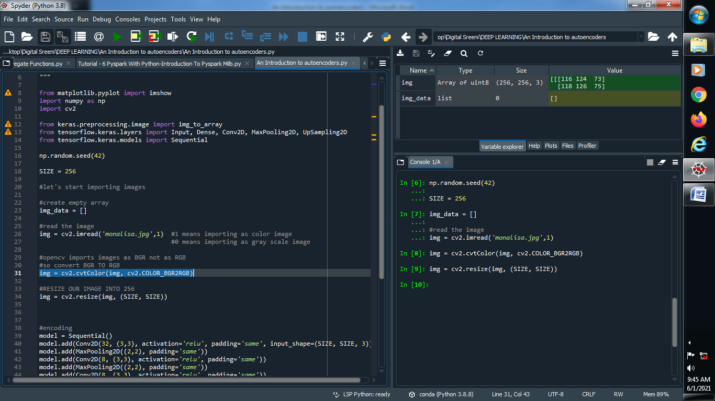

**(5) Resize our image :**

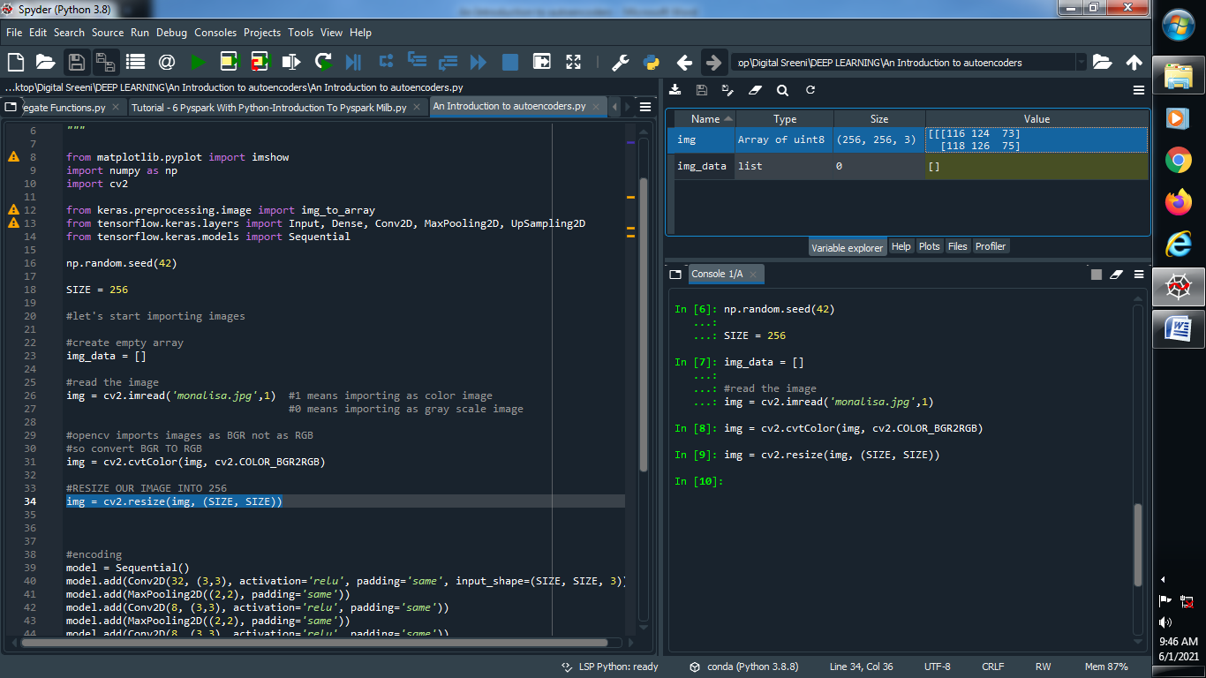

**Output :**



**(6) Add image into array :**

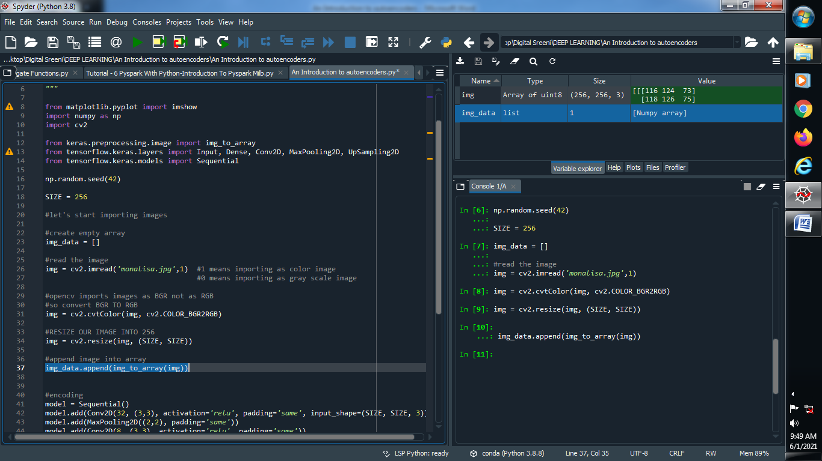

**Output :**



**(7) Reshape our array so we can easily apply many input images[if needed]**

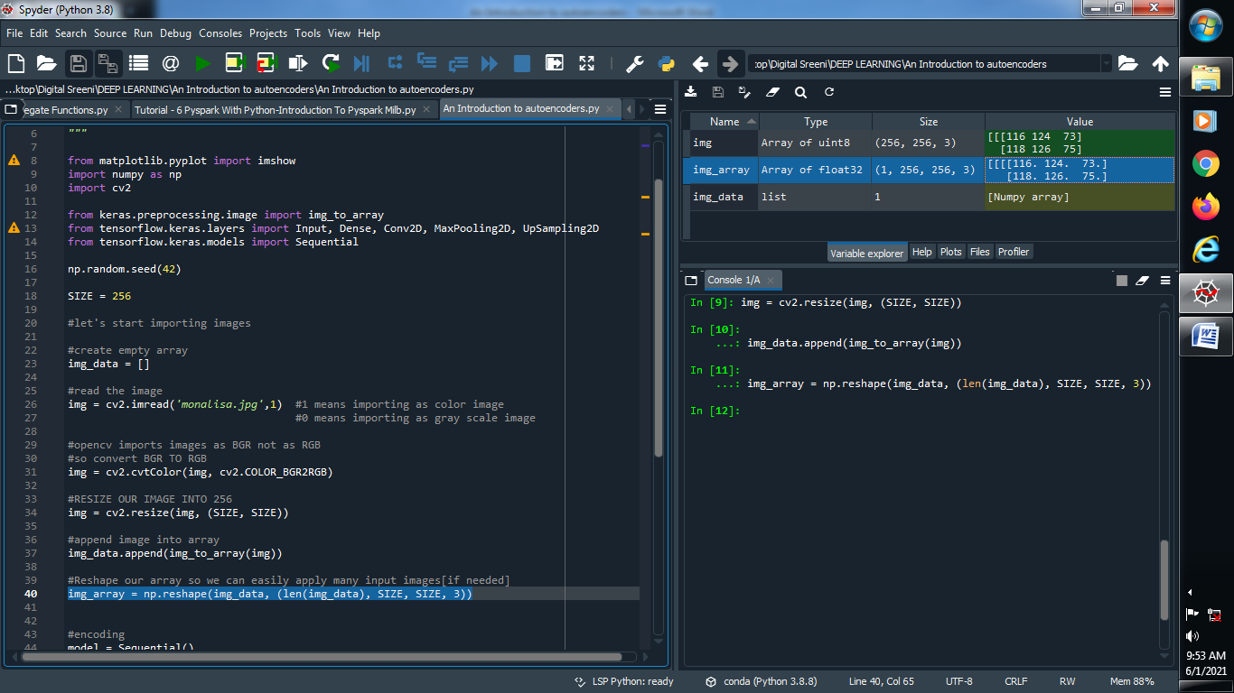

**Output :**

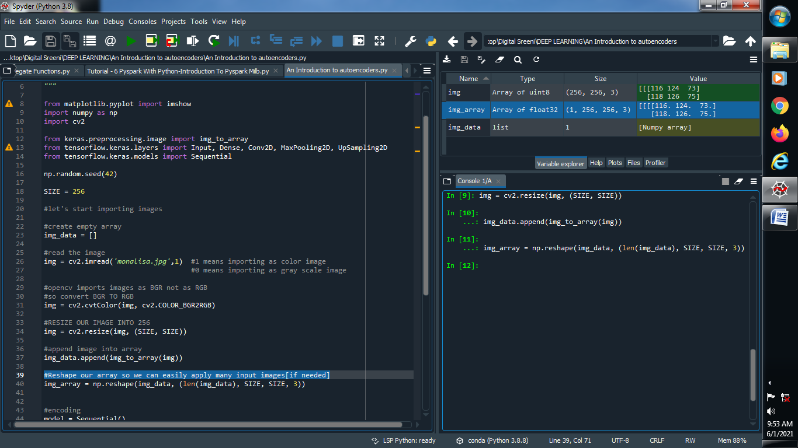

**(8) Normalize our image with divide by 255 so that values range between 0 and 1 :**

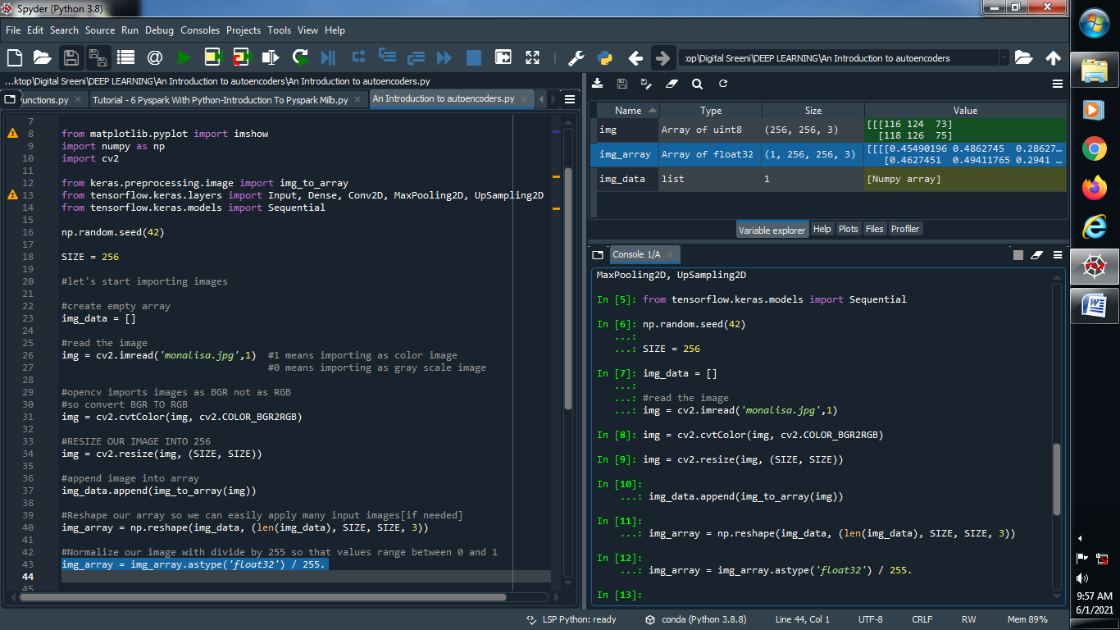



**(9) Encoding and decoding our model :**

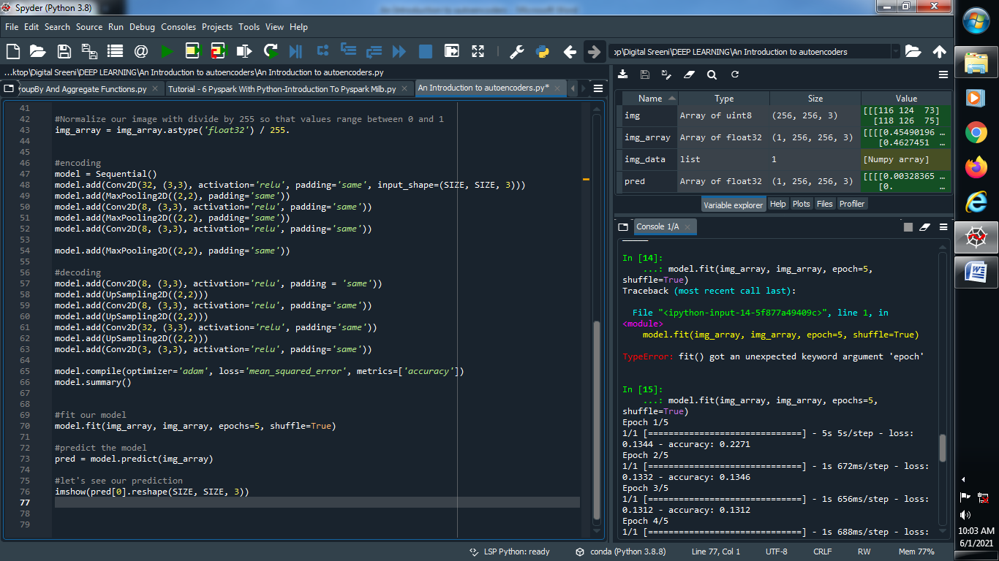

**(10) Fit our model :**

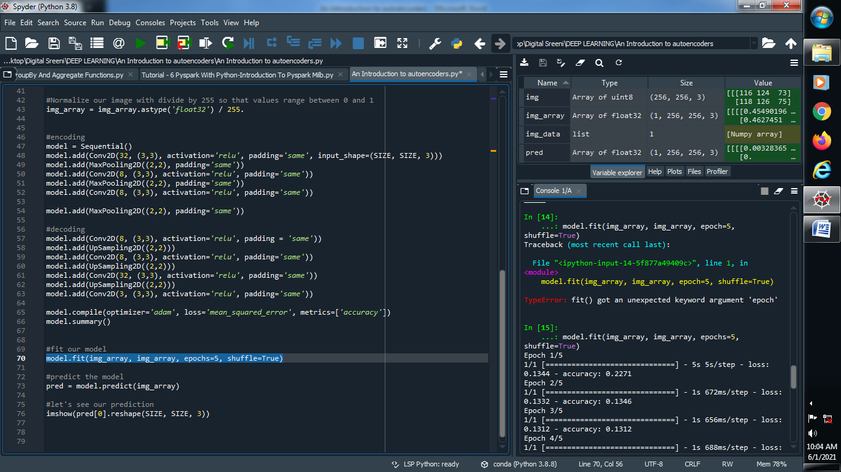

**(11) Predict our model :**

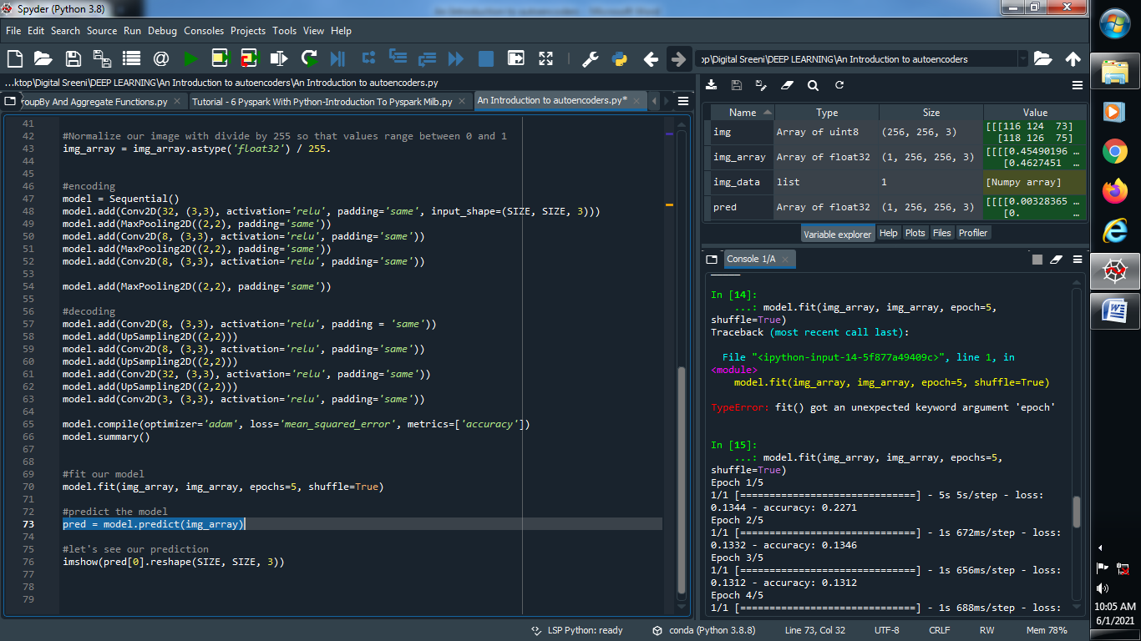

**(12) Let’s see our prediction using imshow :**

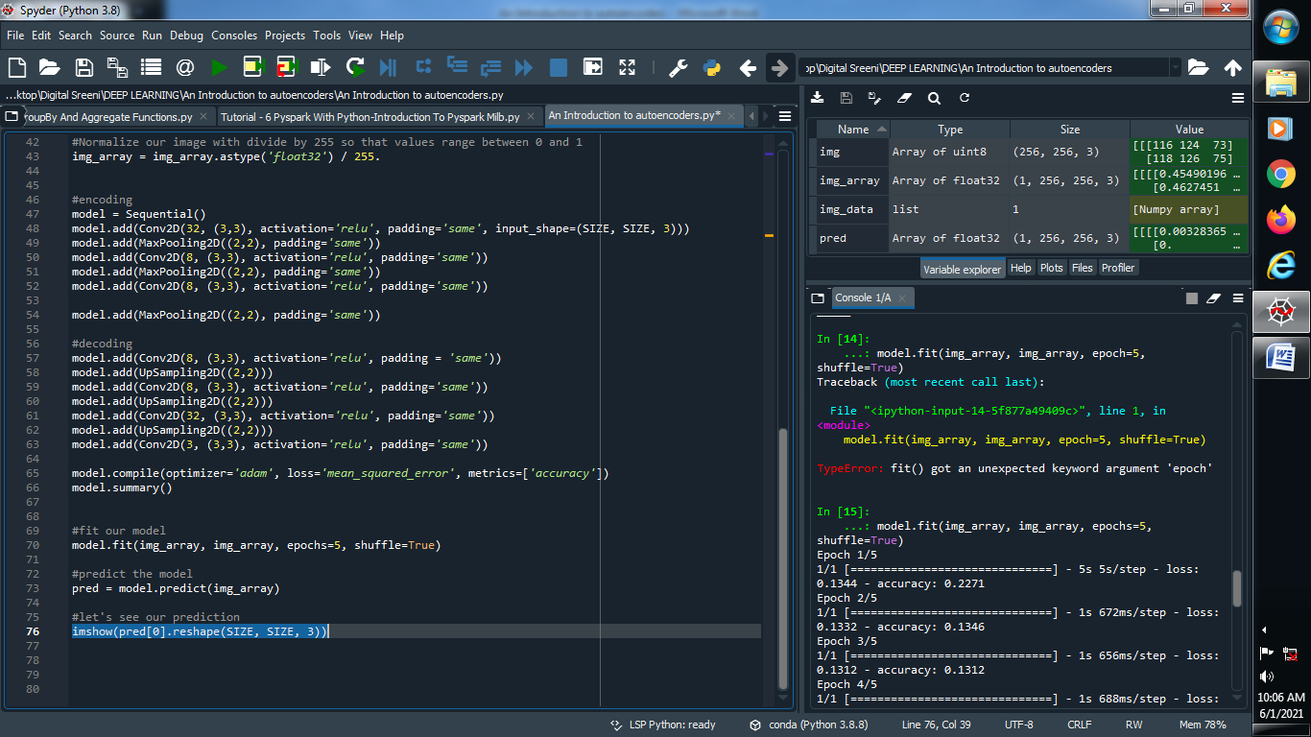

**NOTE : INCREASE NUMBER OF EPOCHS == IMAGE WITH GOOD VISUALIZATION**

**Output :**

**Original Image :**

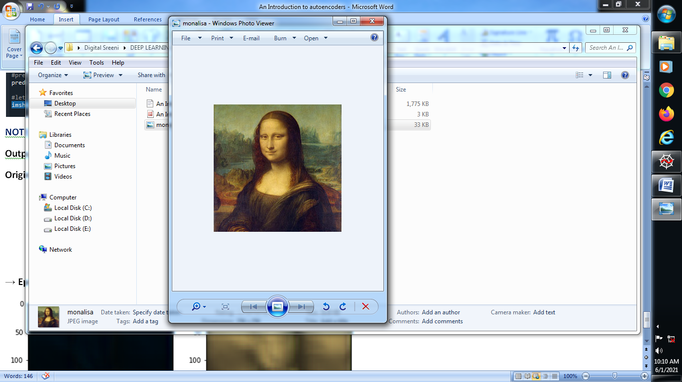

**→ Epochs = 5 → Epochs = 50 →Epochs = 500**

